Oceania Region Reports

FFWPU
UPF&WFWP

July 2016
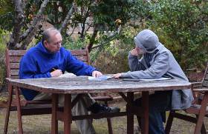
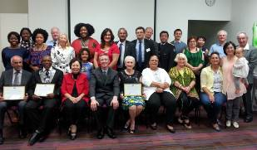

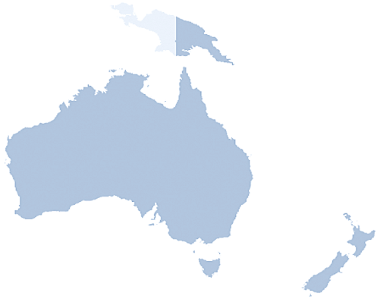

Australia, Sydney

FFWPU Activities
July 2016

Report of the One-Day Special Workshop for
Bestowing the Four Great Holy Items of Cheon Il Guk
17th July

On 17 July 2016, a special workshop to prepare members to receive the four great Holy Items of Cheon Il Guk was conducted in Sydney, Australia. Members from across NSW and Canberra came and attended this workshop. OLT Director, Daniel Meadows, was the Master of Ceremony. We began the program by watching True Mother’s benediction for bestowing the Holy Items of CIG. This was followed by the first presentation from Rev Soon Teck Lim, Sydney Church pastor. The title of this presentation was, “Special Grace and 4 Years of Hope.” Rev Lim shared about the significance and the special grace of the four Holy Items and our attitude to receive them. He also illustrated about the providence of 7-Nation as we invest wholeheartedly for Vision 2020. There was a short Q & A and a break after that.

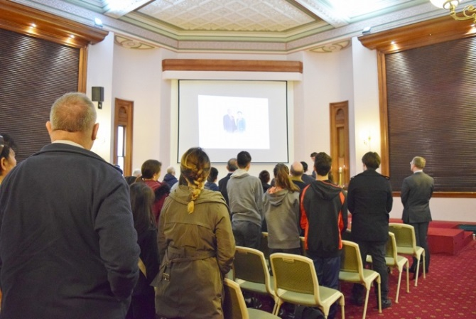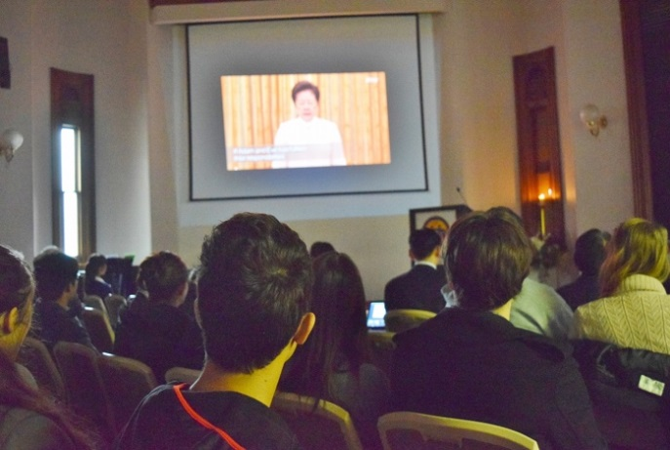

The second presentation was entitled, “Providential History and True Parents.” This presentation illustrated the significance of God’s works of restoration through indemnity in order to prepare a national foundation to send the Messiah. The presentation culminated in the course of True Parents. Rev Lim shared about the responsibilities of members in this era and how we can make a difference in God’s providence in our families, local communities, and the nation. The session concluded with a Q & A session.
This workshop was a preparation to bestow the Four Great Holy Items the following week.

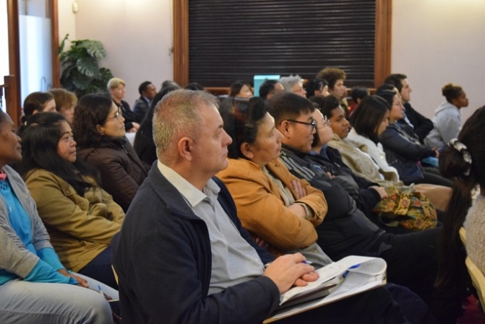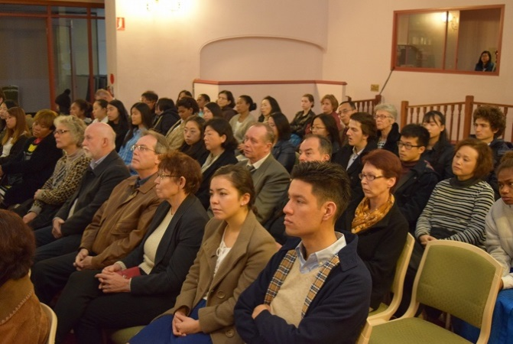

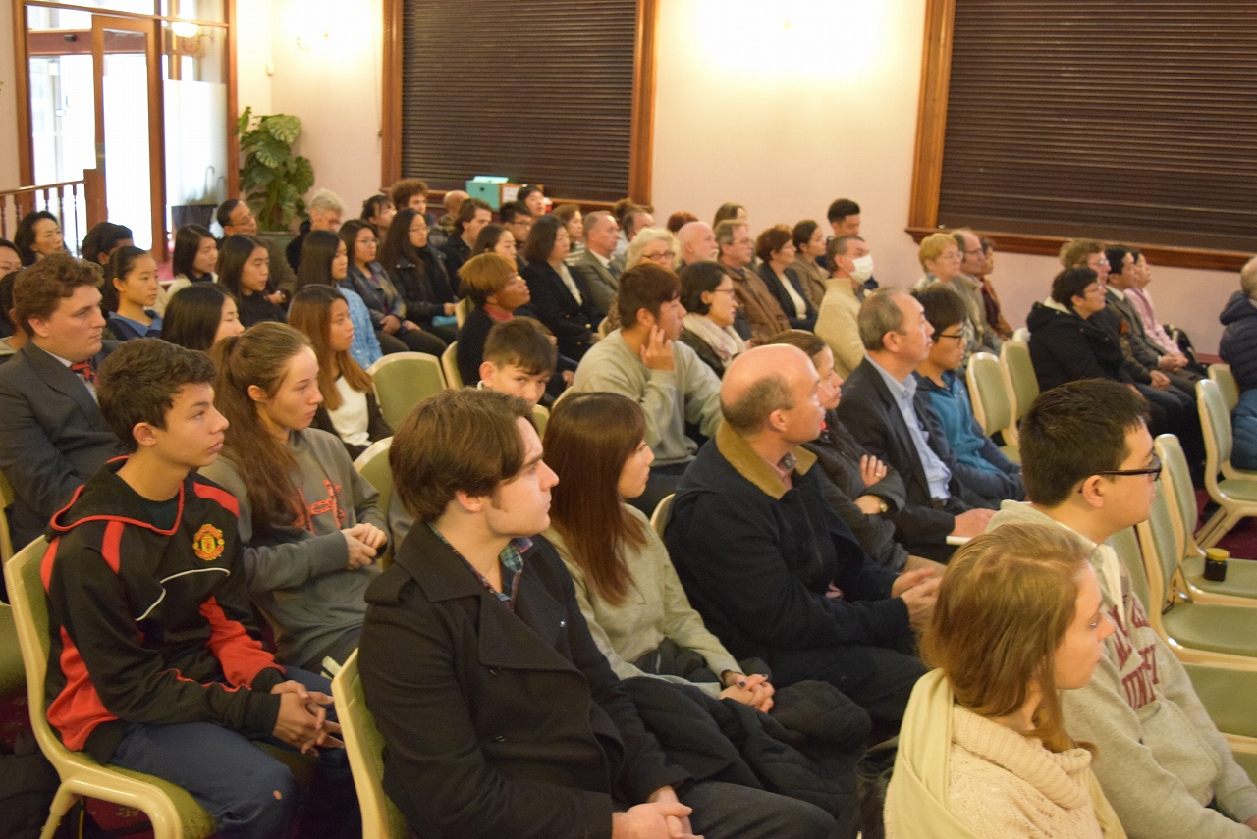

Australia, Sydney

FFWPU Activities
July 2016

Report on the Holy Wine and the Four Great Holy Items Ceremony in Sydney, Australia
24th July

After completing together a 40-day Jeongseong condition to prepare our hearts, FFWPU members in Sydney gathered at the Oceania Peace Embassy on Sunday 24th July to receive the Holy Wine and the Holy Items. There was an atmosphere of reverence and sincere gratitude for Heavenly Parent and True Parents who have sacrificed so much and continued to love us unconditionally even though we fall short of the standard Heaven requires of us. A Holy Spirit atmosphere filled the room.
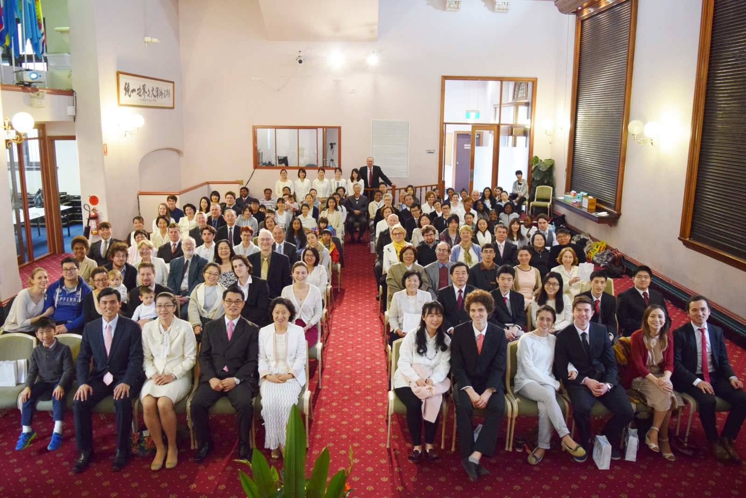
The emcee was the Oceania Regional Director of BFD, Jynene Helland. After singing the Choen Il Guk National Anthem and reciting the Family Pledge, the invocation was given by the National Leader, Rev Soon Teck Lim.

This was followed by a brief presentation on the significance of the Holy Wine and the Holy Items by Jynene Helland and then Oceania Continental Leader, Rev Jong Deug Yoo. Jynene spoke about True Mother’s heart to forgive us, and Mother’s desire for us to make a new start in our lives. Rev Yoo, spoke about True Mother’s serious commitment to Vision 2020 and establishing a Cheon Il Guk nation and fulfilling Heavenly Parent’s hopes and dreams.

Then members participated in the Holy Wine Ceremony and received the Holy Items. The video of True Mother’s prayer, bestowing the Holy Items was shown and the ceremony concluded with a congratulatory song, ‘You Raise me Up’ and ‘Longing for Mt. Kumgam’ by Mrs Richardson and three cheers of eog mansei.
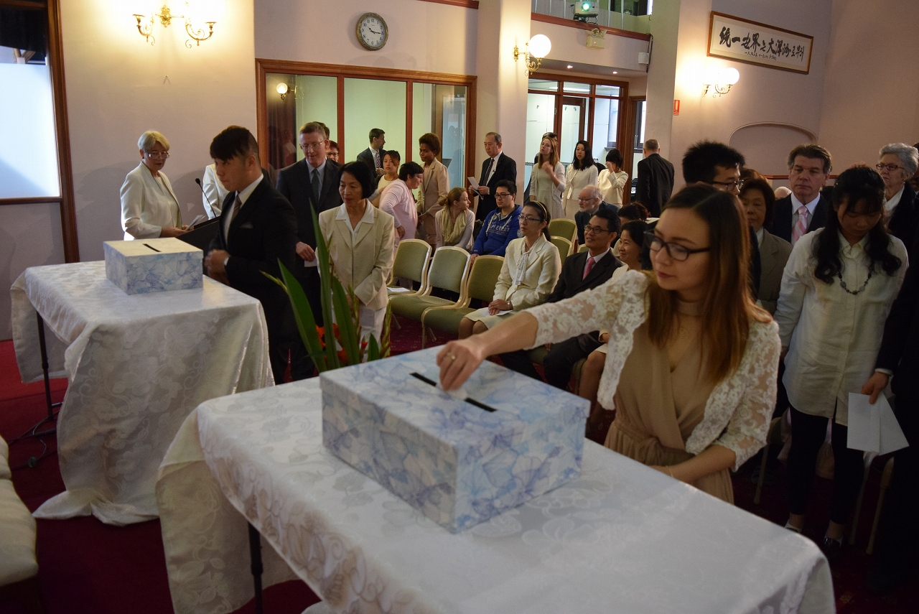
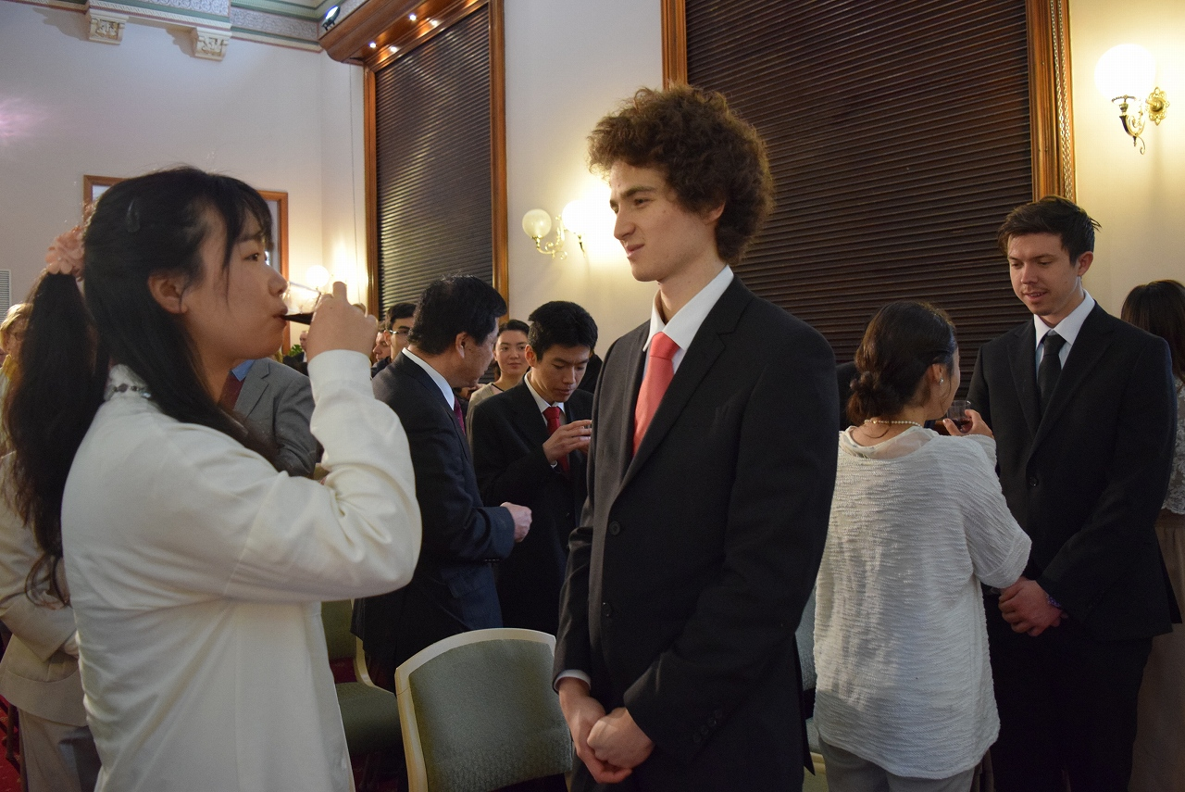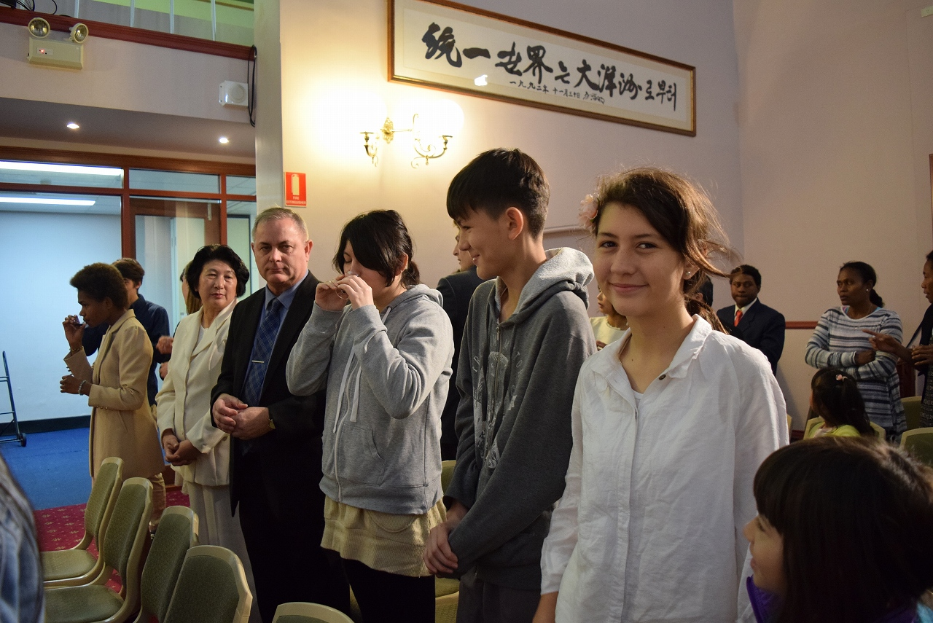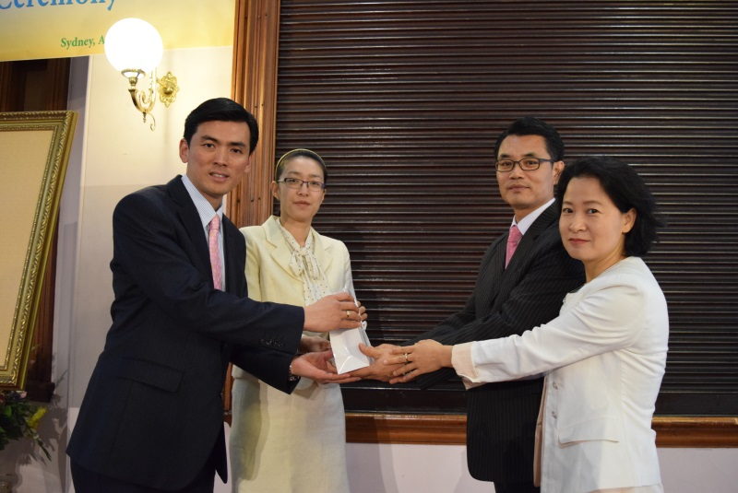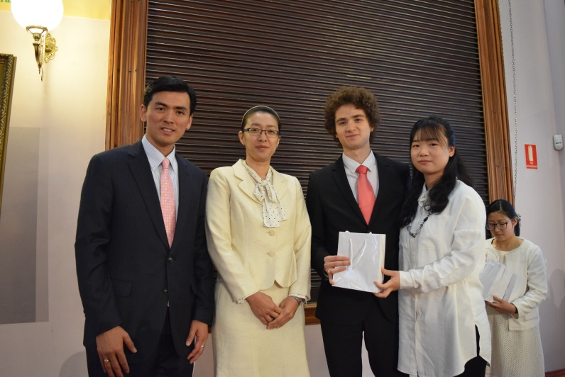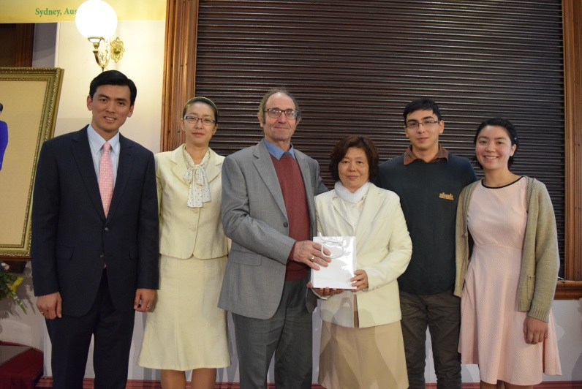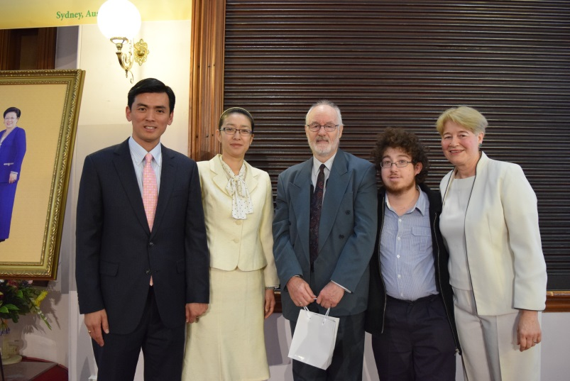
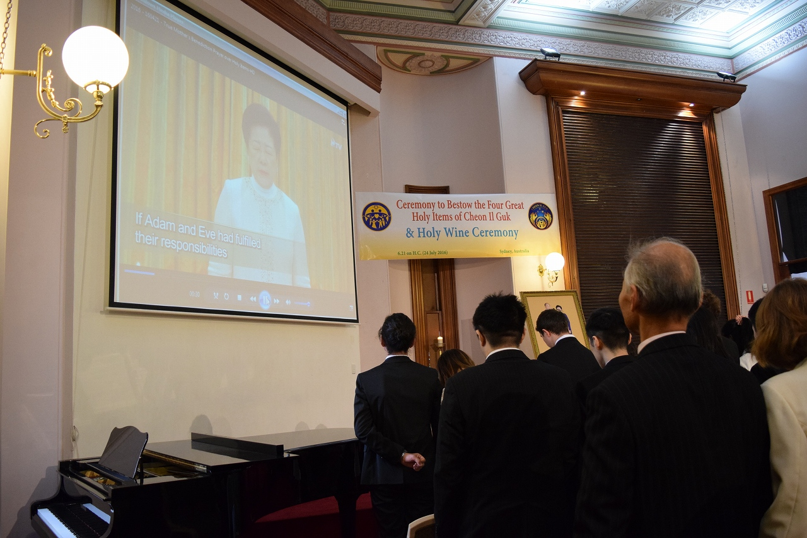
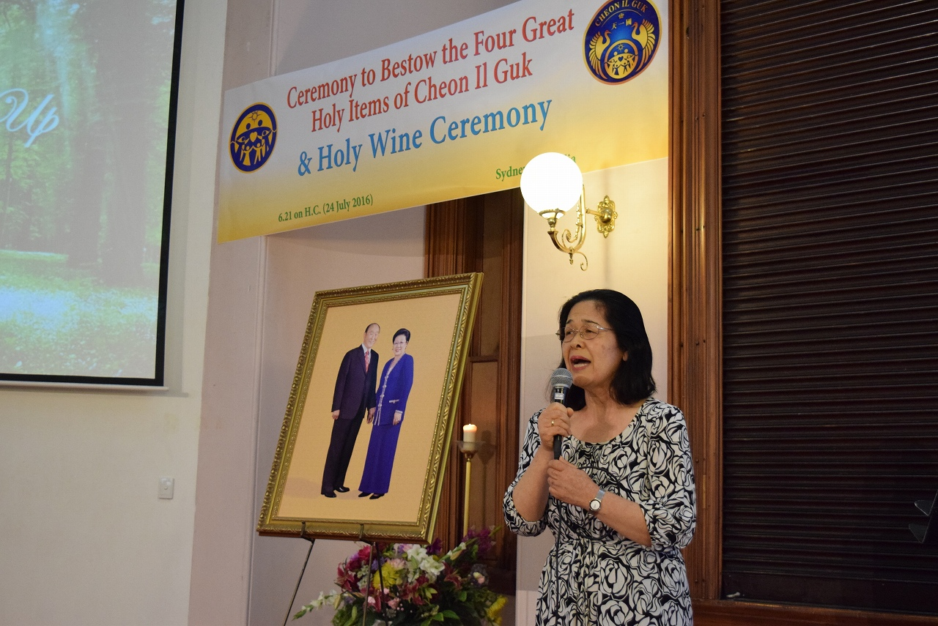

Australia, Melbourne

FFWPU Activities
July 2016

Report for the One Day Workshop
3rd July

Rick Mclnerheney was the MC and welcomed all. We sang two holy songs before watching the video of True Parents’ Benediction prayer. Michael offered an opening prayer.

The First presentation was done by Rev. Soon Teck Lim. ‘Guidance on the Special Grace bestowed through the Four Great Holy Items of CIG and Holy Wine Ceremony’ and vision for 2020 as four years of great hope.
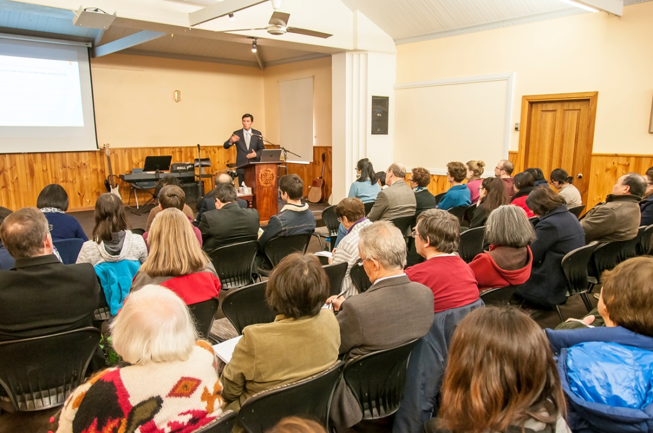

The second presentation was given by Rev Arai, ‘God’s Providence and the Second Advent.’
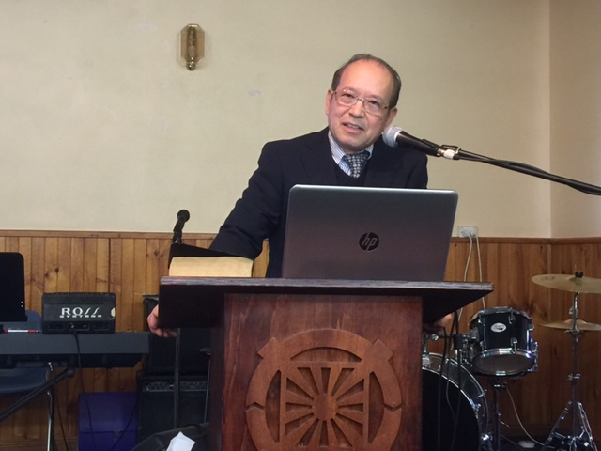
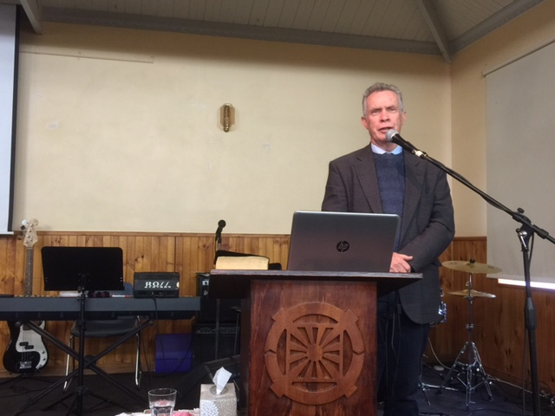
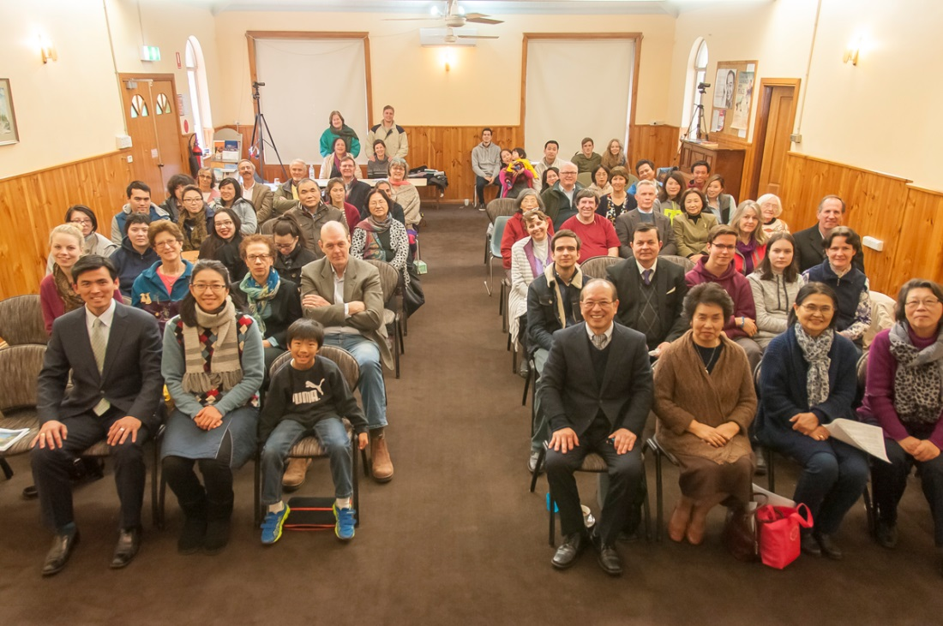
30 Families and 57 members were in attendance. We truly appreciate Rev. Lim’s presentation.
We are planning the Holy Wine ceremony to take place on 24th July, 2016.

Report by Pastor of Victoria

Australia, Melbourne

FFWPU Activities
July 2016

Report of Sunday Service and Farewell & Welcome
The former & New Victorian Council.
10th July

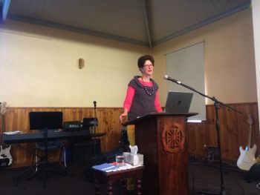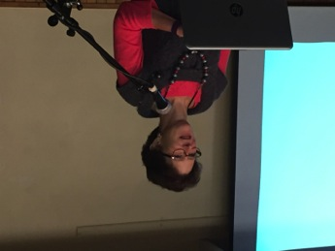

We held Sunday Service and the guest Speaker was Mrs. Colleen Boyd, who is mother of Micah Boyd.
The Sermon title was ‘Creating Community’. She began her sermon by introducing herself briefly. She joined the Oakland church and was on the National MFT for five years. She experienced lots of struggle but survived. Then she pioneered Uruguay with husband as a missionary 20 years.
She had experienced many communities: Mormon, Jewish etc, and saw how they help each other. At Bridgeport University, where she and Steven, her husband work, she always tried to take care of others.

How we can build community?
- Get to know each other
- Help those in need
- Be open to the others idea
-Gently give my opinion, I can always learn
Listen & open my mind to listen to other’s opinions
- Be forgiving
- Be vulnerable

Colleen showed us the music video of the special song, “You Raised Me Up”.
It was a moving and heartfelt message and touched us so much.
---------------------------------------------------------------------------------------

Farewell to the former Victoria Council & Welcome to the New Victoria Council

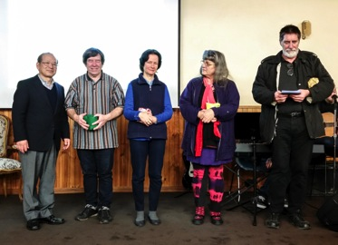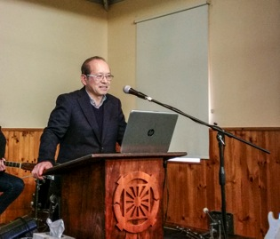
The former Victoria Council: Randall Apps, Jacinta Moreau. Jacinta Darbishire, and James Babb
Absent : Joseph Bellavance, Essie Lausberg and Kouen Kobayashi.-thank you

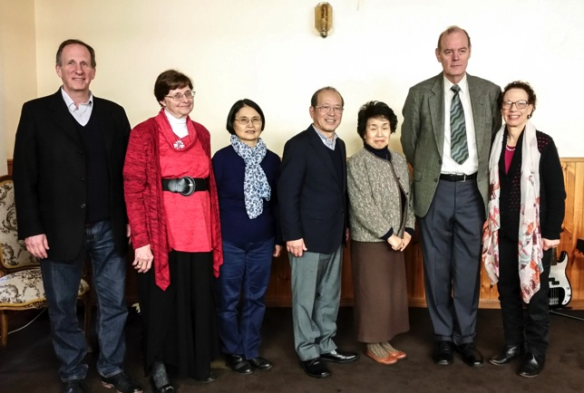
Welcome to the new Victoria Council

John Bellavance(UPF), Elise Hanson(WFWP),Tsuneko Babb(Finance)
Michael Treacy(Property-Chairman), Beth Treacy (Sunday Service)
Victoria New Council:
- Victoria Council rules (Developed by the previous Council)
-It will be checked and amended by this new council.
- Terms: July 2016 to June 2017
- Regular meeting - the contents of the meeting will be distributed via The ‘Weekly Update’
- Blessed Family department, Education, Sunday School will elect a representative each to the Victoria Council when their organisation becomes active.

We appreciate the former council’s members who have been involving and serving 1 years and 3 months (March 2015- June 2016), they started with difficulty, but they contributed a lot and we truly thank them.

Welcome to New VC members, we like to work together and build up a wonderful community.

Best Wishes,
Pastor

Australia, Melbourne

FFWPU Activities
July 2016

Holy Wine Ceremony at the Belgrave Church
13th July

We held Holy Wine Ceremony for the families who cannot attend on 24th July.
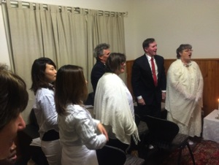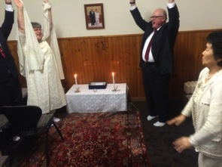
Sang CIG Anthem Eog Mansei !!
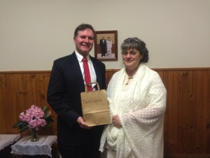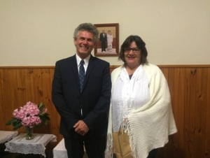
Ian & Jacinta Darbishire Ross& Candace Robertson
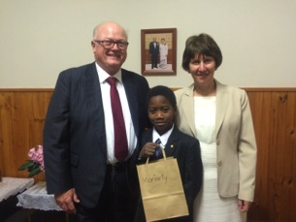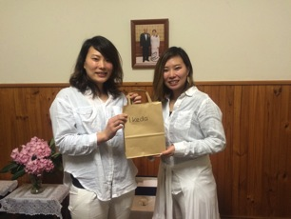
Calros, Douglas & Mary Moriarty Tomoyo & Kayo Ikeda
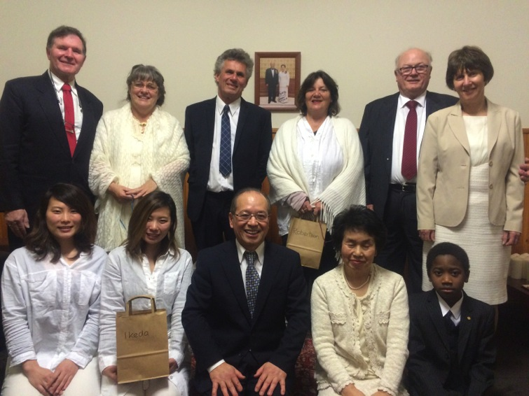
We sang CIG Anthem and recited Family pledge together, then after the
Pastor’s prayer, Ian read about the holy Items and Holy Wine ceremony.
Participants submitted their resolutions and the holy wine was distributed
Each family and children, then the Holy Items was bestowed to each family.
Pastor offered the Benediction prayer and Douglas Moriarty shouted
Three cheers of Eog Mansei.

We thanked Mrs. Hanson, Beth, James and Tsuneko san’s great support.

Best Wishes,
Pastor

Australia, Melbourne

FFWPU Activities
July 2016

Report for the Holy Wine Ceremony at The Anania Family
16th July

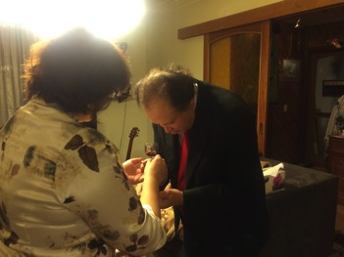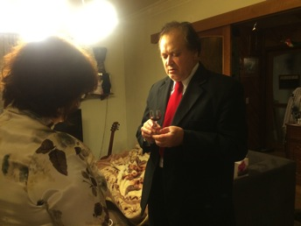

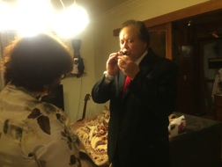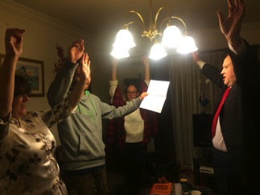

Doss lead the three cheers of Eog Mansei.

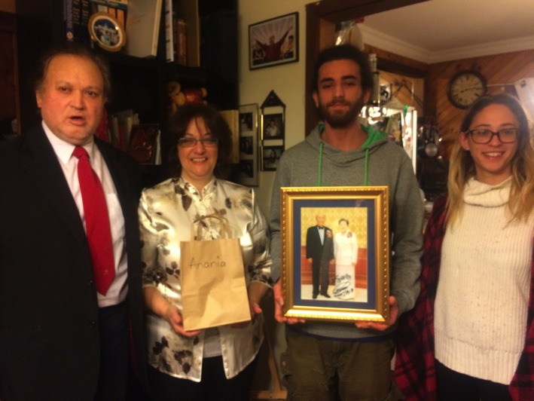

We visited Anania Home just before 7:00pm, and Tim was sleeping
Well and looked not wake up for the Holy Wine Ceremony.

When we prepared the ceremony, He wake up and he decided himself
To change the cloth.
We sang CIG Anthem, recited Family pledge, after Pastor’s prayer,
Irene read the Holy Items, Special Grace meaning,, then The Anania
Families received the Holy Wine and Holy items.

After Pastor’s benediction prayer, Doss led the three cheers of
Eog mansei,
Aju !
Pastor

Australia, Melbourne

FFWPU Activities
July 2016

Bestowing of the Great Four Holy Items
and Holy Wine ceremony
24th July

Officiator: Reverend and Mrs. Arai
Emcee : Michael Treacy

* Cheon II Guk Anthem, & Grace of the Holy Garden
* Family Pledge 1-8

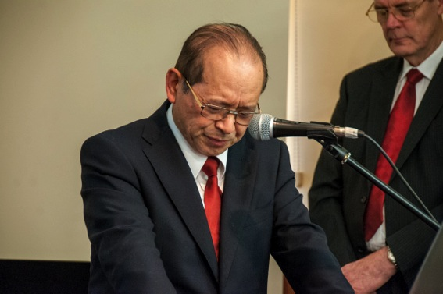
Invocation: prayer by Reverent Arai

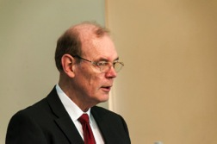
Explanation about the Holy Items of CIG & Address on the significance of the Holy Wine ceremony: MC Michael Treacy
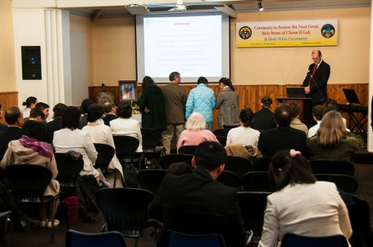
Participants submit statements affirming their resolve

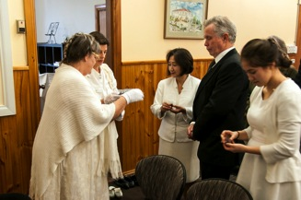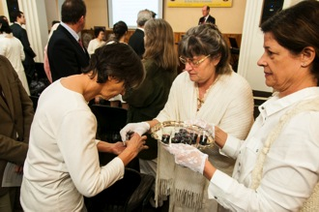

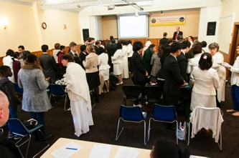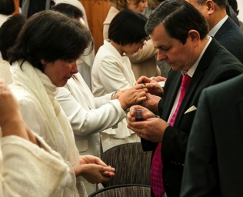

Reverend and Mrs. Arai give Holy Wine to the families

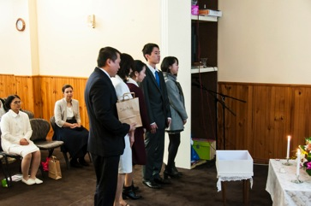
Bestowing the Holy Items of Cheon II Guk to the families

- Benediction Prayer L Video of true Mother’s prayer.

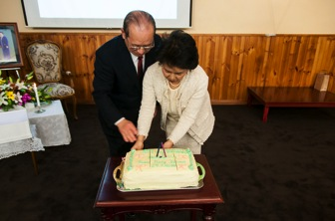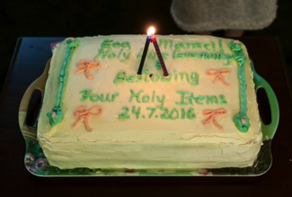
Congratulation for the Holy Wine Ceremony!
-Cake Cut!!

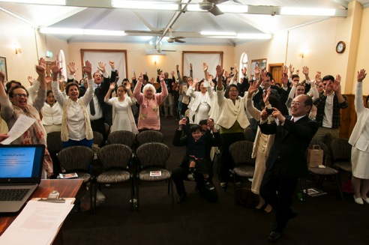
* Three cheers of Eog Mansei !

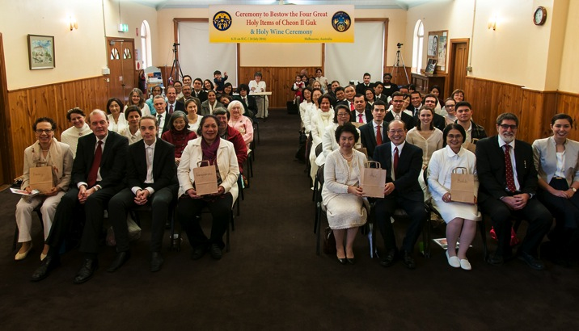
We sincerely thanked and expressed our heart of gratitude to
Heavenly Parent and True Parent.

FFWPU Activities
July 2016
Australia, Brisbane

Report of the One-Day Special Workshop for
Bestowing the Four Great Holy Items of Cheon Il Guk
10th July

In line with the condition to receive Special grace at this historical time, Rev. Soon Teck Lim visited Brisbane on the 10th July 2016.
Held at the New Farm Library meeting room, two sessions presented by Rev.Lim covered the meaning of the Holy Items and the significance of Special Grace at this time and an overview of the history of restoration. Coming on the conditions that True Mother has set since True Father's Seonghwa, the Holy Items represent a chance for renewal and change.
In accordance with the importance of the condition, the Acero family came from Townsville (1300km) and 17 other first and second generation members attended.
Report by Kim Raymond.
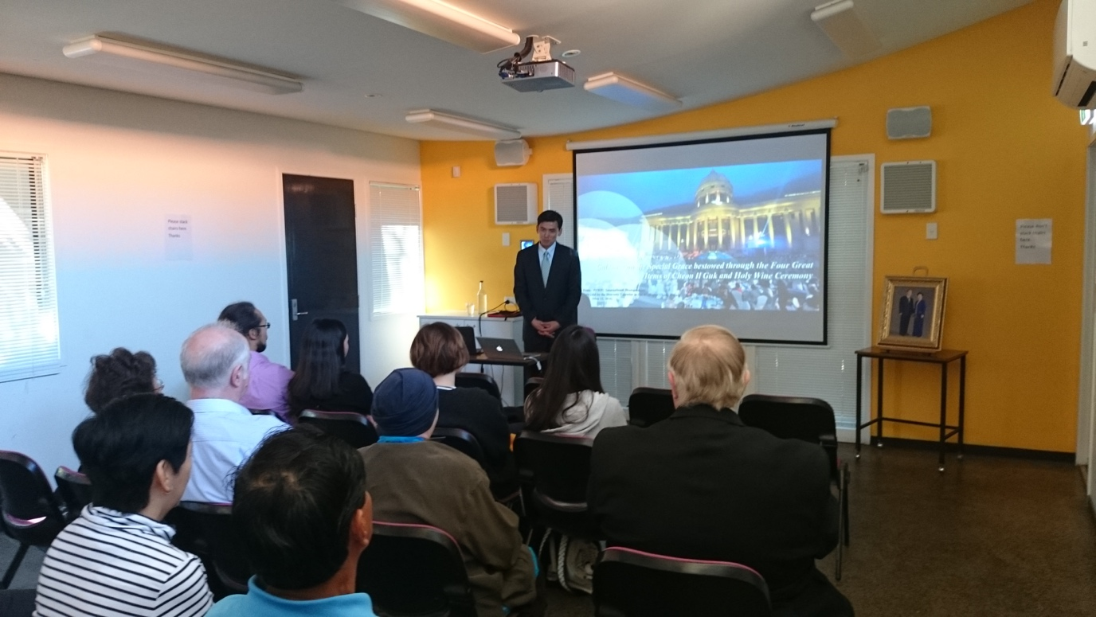

Australia, Brisbane

UPF and WFWP Activities
July 2016

RYS’ Youth Forum
27th July

UPF and WFWP Queensland sponsored a Religious Youth Service (RYS) Youth Forum, on the topic “Peace & Environment” attended by almost 20 young people, and 15 Ambassadors for Peace (AFPs) and members of UPF and WFWP.
The MC was Steve Evans of UPF Queensland. The program began with an Acknowledgement of Country by the president of Logan Elders and Ambassador for Peace Aunty Peggy Tidyman.

Mamiko Rattley, chair of UPF and WFWP Queensland, welcomed all participants, especially young people. She said UPF and WFWP are very happy to sponsor this forum which provides an opportunity for young people of different faiths and cultures to discuss ways to work together for crucial issues like peace and the environment.

Representing AFPs in Queensland, Mr Surendra Prasad OAM greeted everyone.

Next three speakers were:
– Yejeon Degeer, Vice president of WFWP Queensland, who gave a PowerPoint presentation to introduce RYS Queensland.
– Ms Anne Clarke OAM, Executive Officer of the Oxley Creek Catchment Association, who explained her lifelong work to keep Oxley water clean. She asked everyone to be mindful of how our wasteful lifestyle cause damage in nature around us.
– Miss Sam Nolan, Quaker Earthcare, who described their work for the environment and her belief that people in faith communities need to lead the way of conservation.

There was a question and answer session on the two talks on the environment.

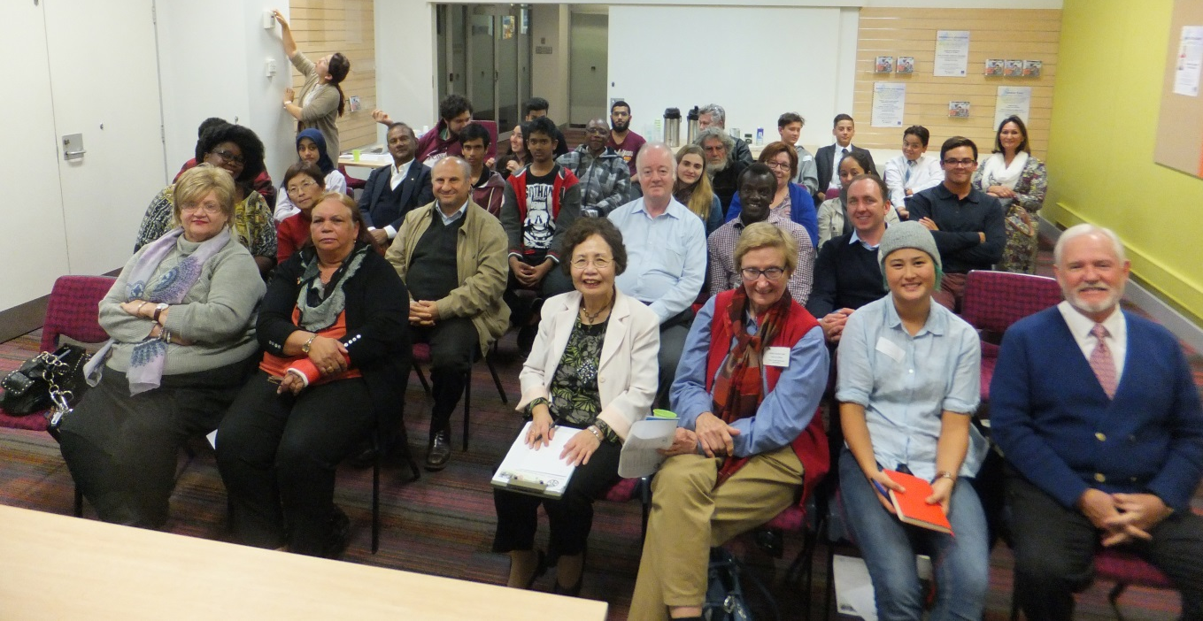
Group photo
After the talks, AFP Ms Sharon Orapeleng skilfully led a discussion with the young participants who are from different faith communities (Christian, Muslim, Hindu and Sikh). The topic was how young people can promote peace and possible projects RYS can adopt to encourage more young people to engage in dialogue and collaborate for peace beyond their own faith communities.
Many of them were eager to join discussion. The General Manager of Multicultural Youth Queensland, Etienne Roux, shared how he and his youth leader Paul Joseph organise projects with thousands of young people to promote harmony and Peace in his local council area. Etienne and Paul are happy to help the RYS initiative.
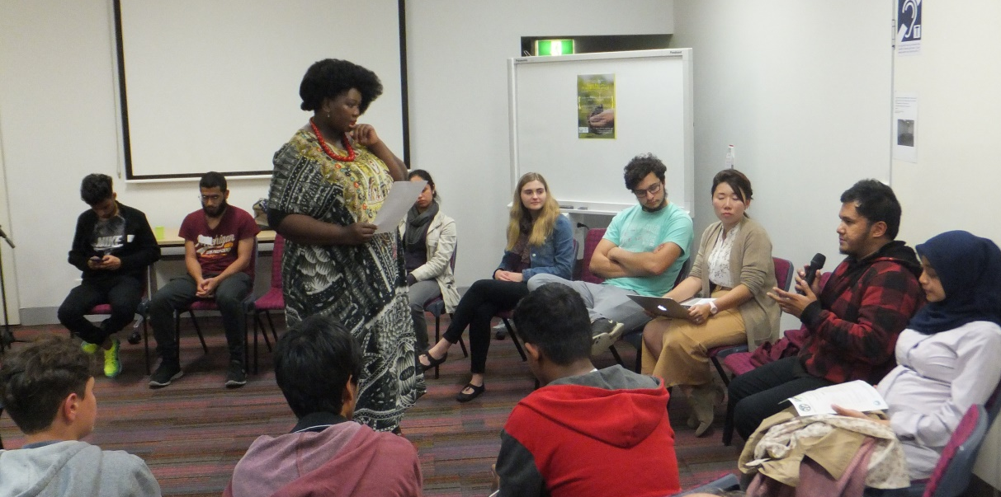
Sharon leading discussion
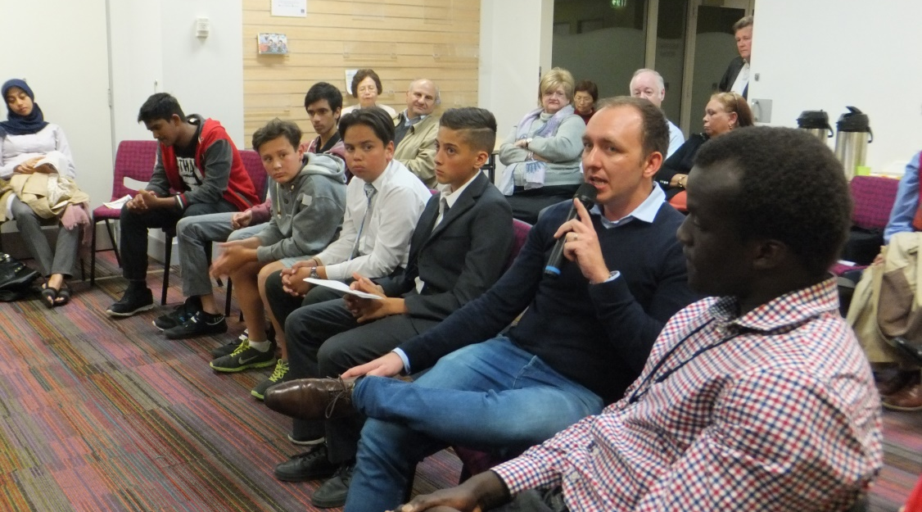
Etienne & Paul sharing their work with Multicultural Youth Queensland
To conclude Yejeong DeGeer suggested creating a Facebook page to keep in touch with those who are open to get involved with RYS Queensland.
The program finished with networking over supper. It was an inspiring gathering with young participants willing to collaborate for future projects for peace.

Report by Mamiko Rattley

