Oceania Region Reports

FFWPU
UPF&WFWP

August 2016
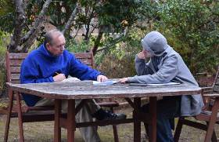
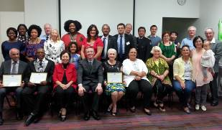

Australia, Sydney

FFWPU Activities
August 2016

The 26th 7.1 Jeol and 20th 7.8 Jeol Celebration
9th August

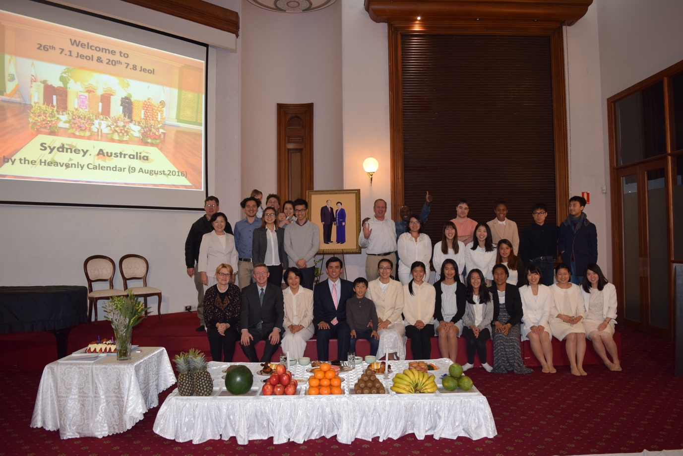

The 26th 7.1 Jeol and 20th 7.8 Jeol were celebrated on Tuesday, 7 July on Heavenly Calendar (9 Aug), 2016 at the National HQ Church in Sydney. Offering table was prepared by blessed wives and centre members. Rev Soon Teck Lim gave the main address and encouraged all presence to inherit True Parents’ victorious foundation and build CIG ideal within our families, communities, and the nation.

Australia, Melbourne

FFWPU Activities
August 2016

Peace Road 2016 MELBOURNE
TF’s 4th Seonghwa Anniversary gathering
28th August

At Novotel Hotel St Kilda
11:00am Steve gave presentation from TF’s Autobiography, and
John Bellavance testified TF’s life course.
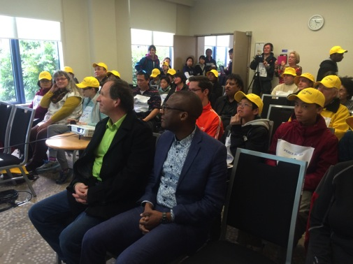
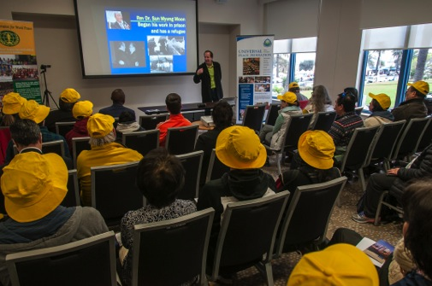

12:00pm Start Peace Road course at Novotel Hotel St Kilda
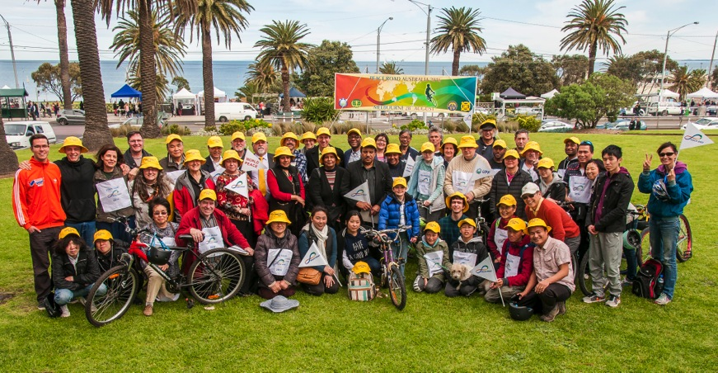

The Second starting location at Catani Garden
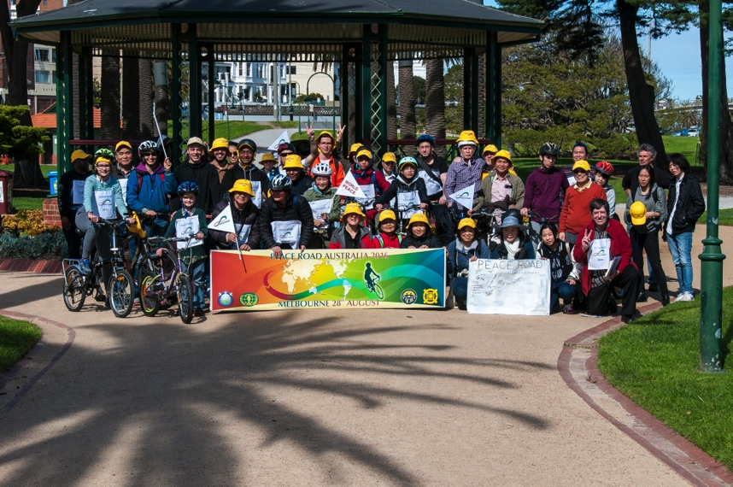

Motor Bike Joined.
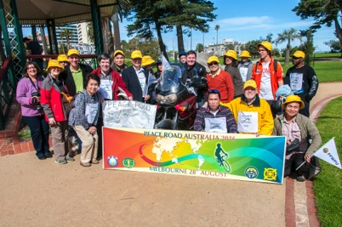

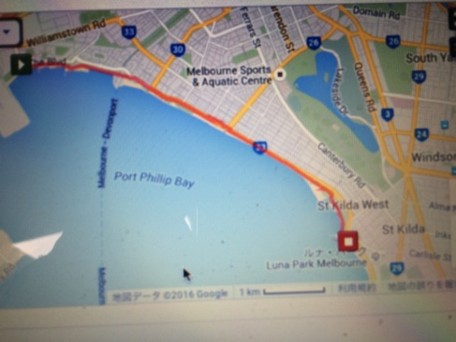
Cycling route : Novotel Hotel to Station Pier, Port Melbourne
One way 6.7km x 2 = Total 13.2 km

Enjoy Cycling and Walking,
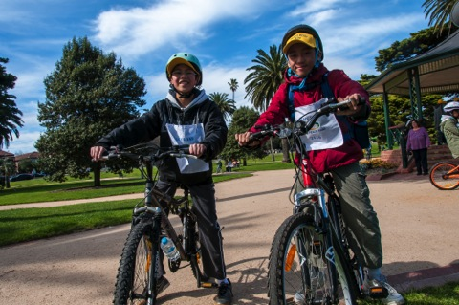
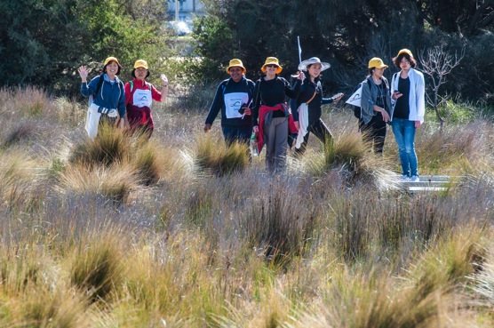

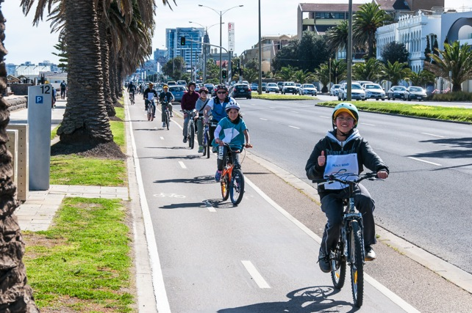

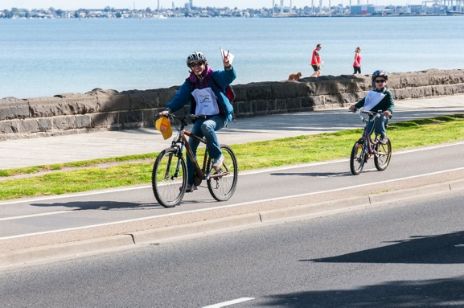

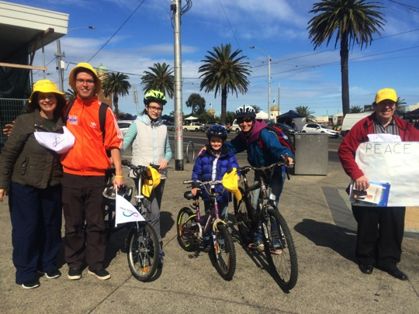
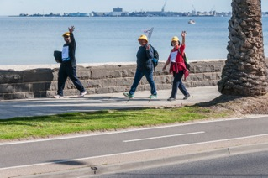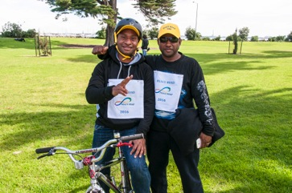
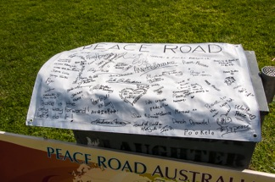

Remark :
Conference ; 11:00am-12:00pm
We gathered at Novotel Hotel St Kilda and held seminar for the True Parent’s peace ideology and achievements.
After Rev John’s opening prayer Steve Sibanda gave presentation “The core principle from True Father’s Autobiography”. And John Bellavance testified TF’s life course.

Peace Road; 1:00pm-2:00pm
After the Seminar, we gathered and started cycling and walking, and joined to the second location at the Catani garden.

This time we selected Melbourne’s beach side cycling course which is beautiful ocean view and very safety for children, for cycling and walking.
It was one of the best weather this year, and all the attendants were enjoyed lots and youth, children and parent having good time together with fantastic nature.

We try to realize the idea of One Family under God and also we like to connect international peace network of Parliamentarians for peace and establish international association of parliamentarian for Peace.

Best Wishes,
Pastor/ Sate Leader of Victoria

Australia, Melbourne

FFWPU Activities
August 2016

Seong Hwa Ceremony
For
Timothy Taupiri Anania
27th August

9:30am Viewing-Flower offering
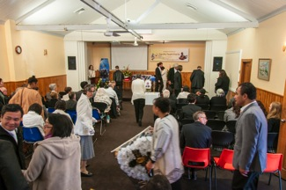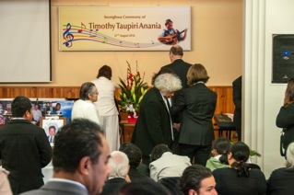

10:00am Opening remarks & Eulogy by MC Mrs. Brenda Muraoka
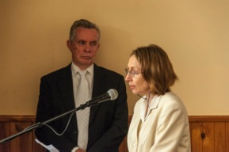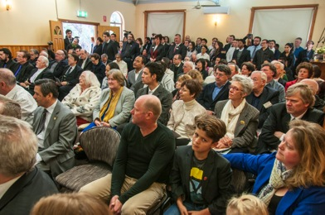

Opening Prayer – Rev Arai,
Seong Hwa Address – Mr. Rick Mclnerheney
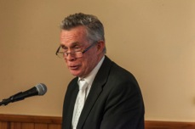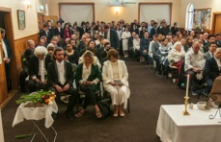
Celebration of Life Video Presentation
Song by Samoan Church
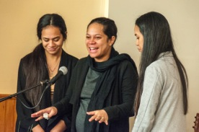

Testimony -Mr Temura Anania
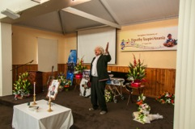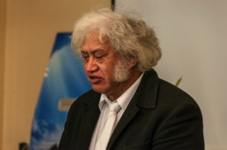

Mr Warwick Dean Ms Katie Ryan
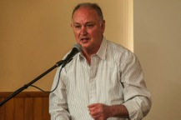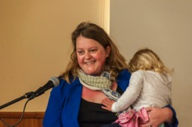

Maori Song- Mr. Temura Anania & NZ Family
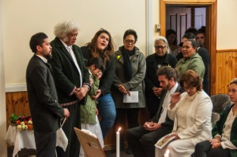
Going to Won Jeon- Springvale Cemetery
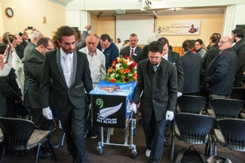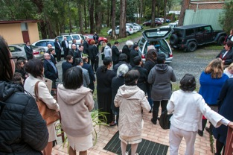

Arrival to Springvale Cemetery
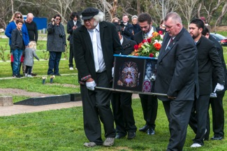

Won Jeon Ceremony MC- Steve Evans
Invocation: Mrs. Brenda Okada
Won Jeon Address - Rev Arai
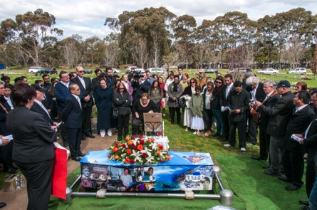
Offering of Flowers and Soil
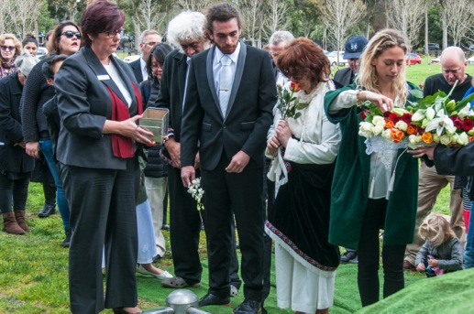

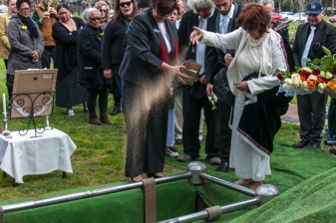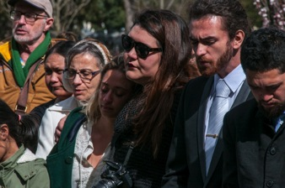

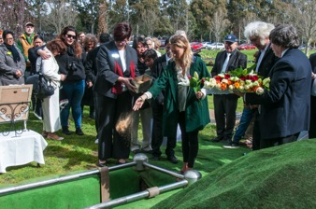

Haka –Led By MR Doss Anania
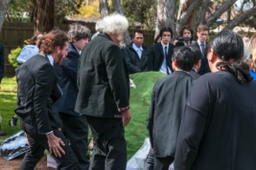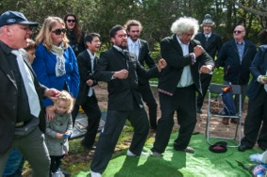

3 Cheers of Oku Mansei- Rev Arai
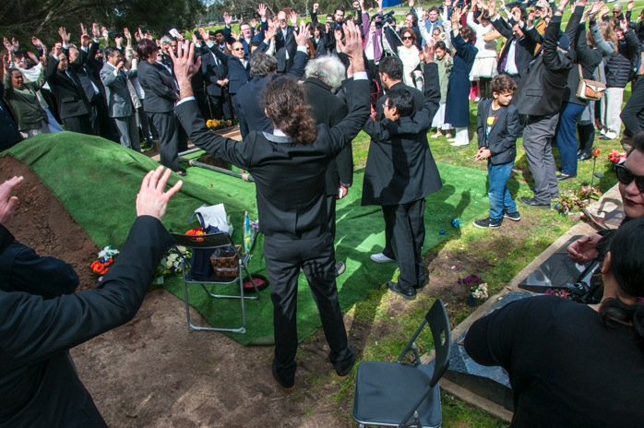
Farewell to Dear Tim forever,
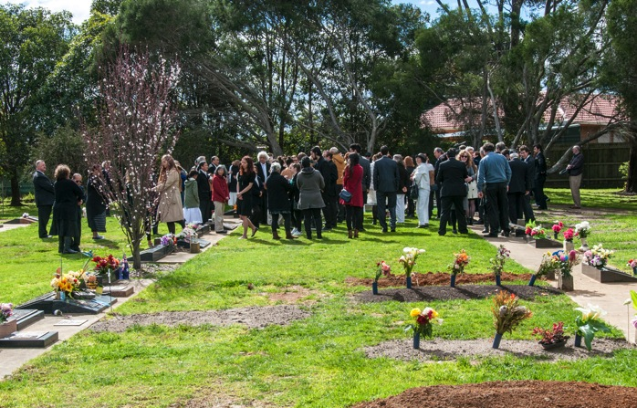

Celebration of Life,
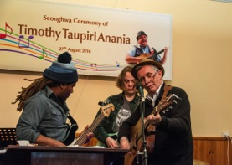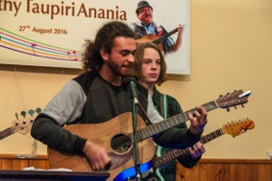
Hangi by Temura and Family
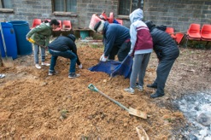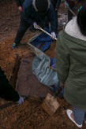

Remarks:

It was a truly heart moving Seong Hwa ceremony.
More than 170 people attended. With no extra chairs available many were standing during the ceremony.

People came from, NSW, Adelaide, Tasmania, NZ and Qld. There were many 2nd generation as well as 1st generation who seldom came to church. Rev Stone attended privately and Carl Redmond & son Dan Young also attended as did Lance and Lucina Clarke, John and Heidi McLeod, Steven Auwaki and Tony Wariri.

Besides FFWPU families there was generous representation from the Samoan church, Monash Men’s shed Peace Ambassador, neighbours, friends of Doss and Tammie there to support them, friends and business associates of Irene as well as whanau from NZ. A number of poems and songs were also written for Tim by friends which will be cherished by the family.

Brenda did a remarkable job as MC, keeping everything flowing smoothly and to a strict time table with heart and humour and Rev Rick was able to interweave the meaning of the Seong Hwa ceremony with a joyful message testifying to Tim’s warm personality and how he touched so many people.

The Samoan choir members testified with tears how Tim gave them joy and taught them many songs that they now sing proudly as part of their service. They gave a stunning performance of two of their favourites that moved the audience.

Countless messages of sadness and love were sent from so many people such as the National Leaders of NZ and the Solomon Islands, from Queensland and personal messages from many Pacific Islanders and members from around Australia and NZ. The MC managed to pick up a few to share, particularly messages from Tim’s younger brother, Marty, and sister Connie; Susi Evans, Irene’s spiritual mother and Joachim Kuman whose deep and sincere testimony was selected as it best represented the sentiments of the islanders in general.

Temura showed his brotherly love, Warwick, a close music friend, shared his early experience with Tim and offered a Maori song, and Katie thanked Tim and Irene for their love and care for her over the years.

It was amazing to see the turnout at the Won Jon as most of the attendants at the Seung Hwa joined the Won Jeon Ceremony at Springvale Cemetery along with others that had not been able to come all the way out to Belgrave.

The Anania Family, Irene, Doss, Tammie and Temura offered flowers and soil; it was a moment of last respect Tim.

Mrs. Brenda Okada offered the prayer; Rev Arai gave short message for the Won Jeon ceremony, and offered 3 cheers of Eok Mansei.

Doss lead the Haka with his Whanau (Temura, Keanu, Wynyard and kuias in the background) which shook all present to the core and moved us to tears.

After the Won Jeon Ceremony, many joined the Cerebration of Life for Tim, enjoyed Hangi food which was prepared by Temura Family and Doss, and joined in the entertainment.

Mrs. Arai supported the Seong Hwa ceremony, and James made the fantastic banner for Tim’s Seong Hwa ceremony.

Irene expressed the heart of gratitude to the people and families who supported, helped and involved in his life and attended to Tim’s Seonghwa, and she said that she felt love from community in deepest way her 25 life of faith in Church.

Tim’s Eulogy

Timothy Taupiri Anania was born in Huntly, New Zealand into the Ngatiwhatua tribe on the 29th August 1956. Mum was a young 17 year old Maori, dad was an ambitious naval officer who wasn’t about to be tied down, and baby Tim was raised by grandad Jack in a hut at the foot of Mt Taupo.

When Tim was 7 his one role model and source of all that sustains a child, passed away suddenly, leaving him and his siblings Temura, Connie and Martin at the mercy and charity of various relatives. Aunty Katie was the one they called mum for a while and they honoured her till the end of her life.

Time doesn’t stop for anyone but by his mid twenties time was really slowing down for Tim. It was a kind Korean man by the name of Heun Keung Kim, pastor of the NZ Unification Church, who took him under his wing and brought him to Melbourne, Australia with him. I suppose Tim didn’t suspect that he would find his match here. He buckled down, changed his life around and stayed true to the new life style and belief system that our True Parents presented him with.

He loved to tell everyone that his favourite subject in school was ‘lunch’, but that doesn’t mean that Tim shunned education. Everything he knew, and knew how to do, he had taught himself from car mechanics to guitar playing. He had acquired a wealth of information on subjects that were of interest to him especially since computers became a staple in our household. No one taught him how to use that either, but his perseverance and drive had him sitting in front of it squeezing out all the learnings he could.

His humble, stark upbringing made him very resourceful when it came to acquiring material things as well as information (please come and help yourself to his riches) but as the years went by and I wasn’t winning the battle of keeping our spaces clear of material things I came to realise that in his heart what he was doing was collecting things that people had mentioned they needed so that next time they asked he would be able to offer it to them and make them happy. Whether it was fishing rods, leather coats, bicycles, BBQs or sewing machines Tim would get it for you. And then another and another…

There was a part of him that was very protective of women and animals and those weaker than himself. And he was fearless in standing up for them when the need arose. But then, we had some pretty scary moments at home ourselves. Times when Tim was overwhelmed and dominated by elements stronger than his gentle accommodating nature. Times when it took all the strength, resolve and love I had to hang on to the Tim that God had given me.

The spiritual intention behind the 30,000 couples Blessing in 1992, was to overcome barriers of race and culture on an international level. In our couple we bridged a number of gaps: between the oldest and youngest Christian cultures, between the tribal indigenous and one of the oldest civilisations, between black and white, between formally educated and not. Yes there was shouting and tears and even bloodshed but as we grew older we started to notice a peaceful unity, a wordless oneness that will see us into eternity.

He was very proud of his children, as am I. They are the products of our efforts to bring peace and harmony to this world through our personal lives against all odds. That is the legacy we have been entrusted with by our True Parents, and Doss and Tammie have themselves honoured that, to the best of their ability, by their sheer perseverance, their loyalty through thick and thin, their wisdom and love.

Tim mate, we’re not done yet. With me still here and you in spirit world, now more than ever, is the time to get cracking and funkisise this place.

Irene Anania
26.08.2016

Australia, Brisbane

FFWPU Activities
August 2016

Sun Myung Moon Memorial Family Fishing Day
on the 4th Seungwha Anniversary
28th August

Shorncliffe Pier, Queensland. 28th August 2016
The Family Federation for World Peace and Unification, Queensland celebrated the 4th Anniversary of Rev. Sun Myung Moon’s Seungwha with a family fishing day at picturesque Shorncliffe Pier on Moreton Bay.
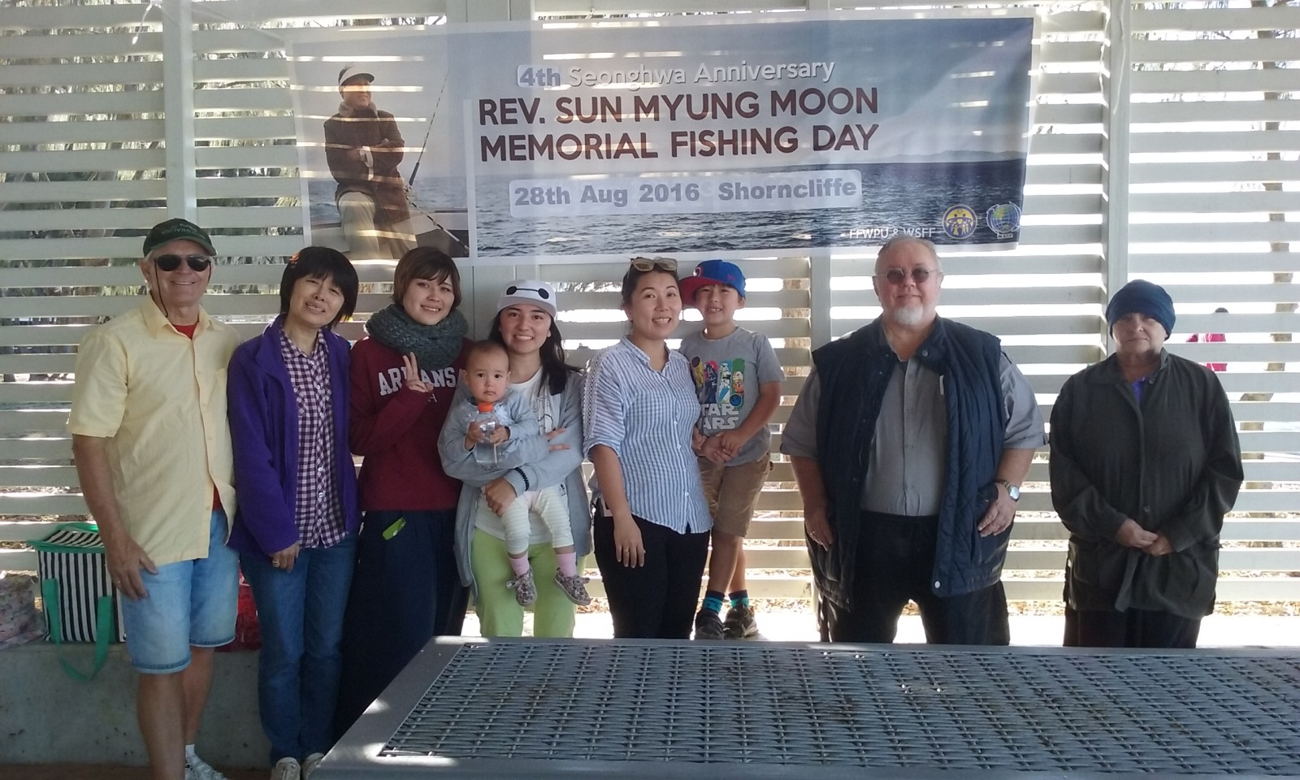

Throughout Rev. Moon’s life he invested physically and spiritually in the Ocean Providence. At many critical moments in providential history True Father spent long hours in all kinds of weather setting spiritual conditions through fishing investment and prayer. It is fitting that he be remembered through a fishing event.

This year instead of the tournament of previous years Donald Coles made available his boat “Kingdom Come” for members to be able to do boat fishing as well as fishing from the pier. Donald and Dr. John Coles invested intensely into preparing the 21 ft. long vessel as it is still in the process of restoration.
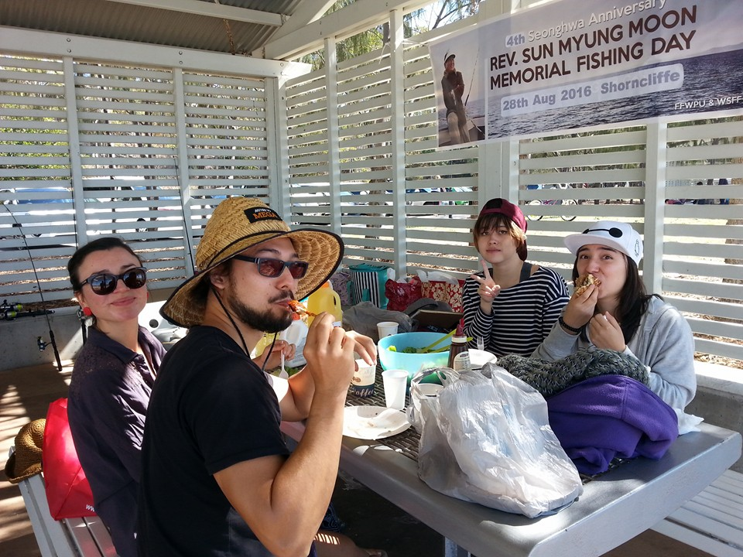
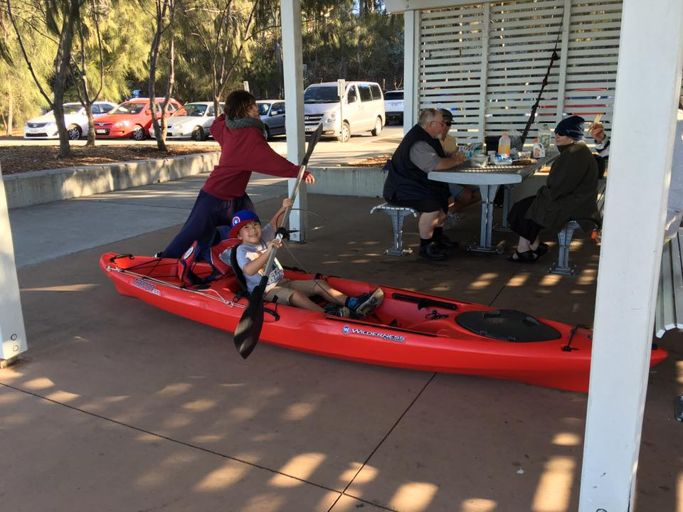
Members gathered at the one of the pavilions in the parkland near the pier and a day of fishing socializing, eating and boating was enjoyed by members and friends of the Unificationist community.
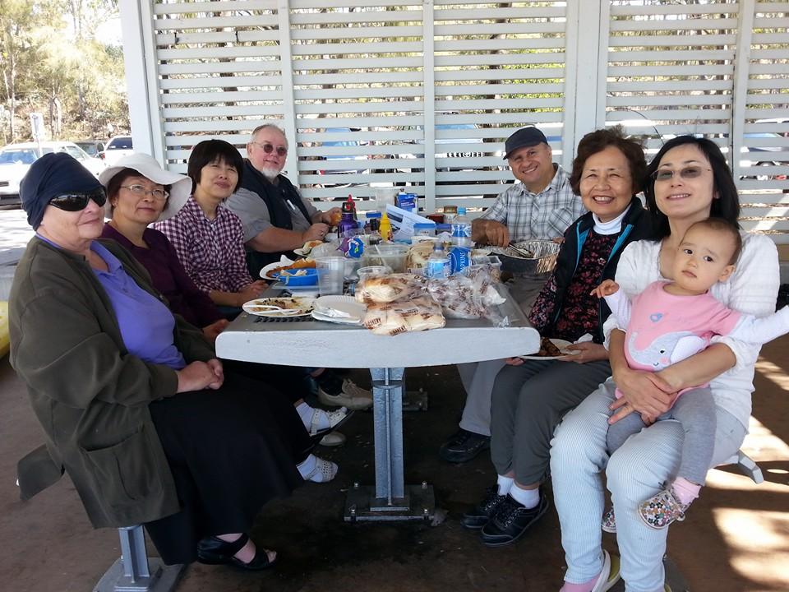
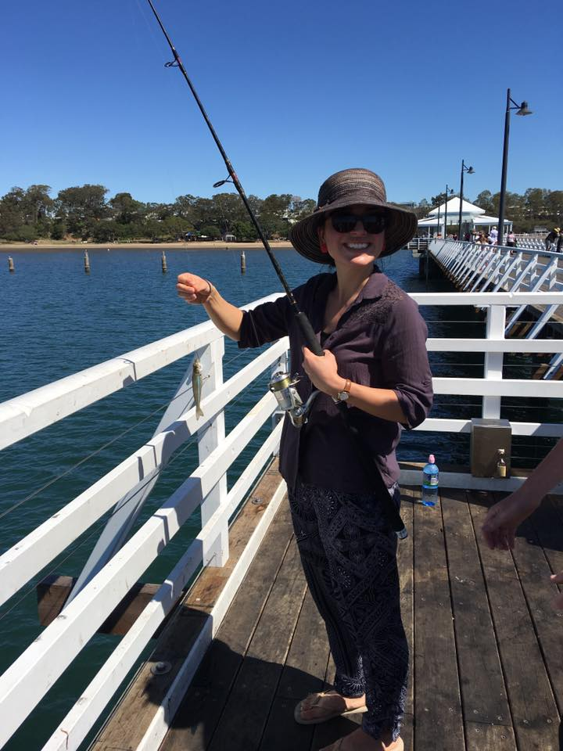

“Kingdom Come” was launched at Cabbage Tree Creek, Sandgate and driven around to the pier where it was used to take members out fishing. The second and third generation particularly enjoyed the boat experience, though one shed tears of disappointment that he hadn’t been able to catch a fish!
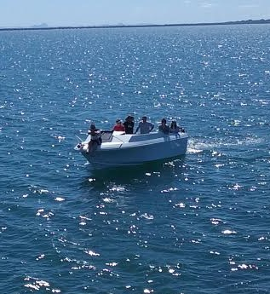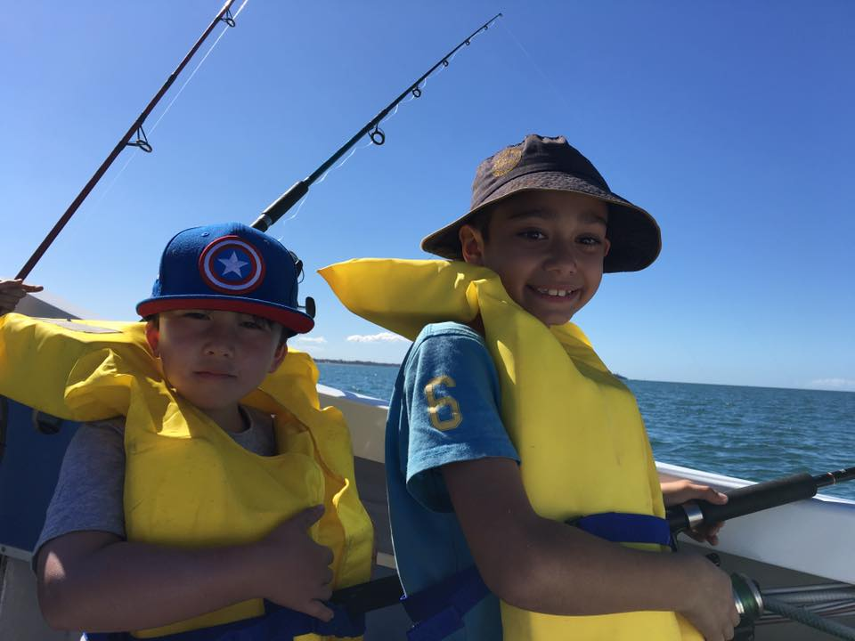
Thanks to all who made the day a fitting memory of True Father and a great example of True Father’s vision for “hobby industry”

Report by Kim Raymond

Australia, Brisbane

FFWPU Activities
August 2016

Report on the Holy Wine Ceremony and
Bequeathal of the Four Great Holy Items
14th August

New Farm Library, Brisbane, Queensland.
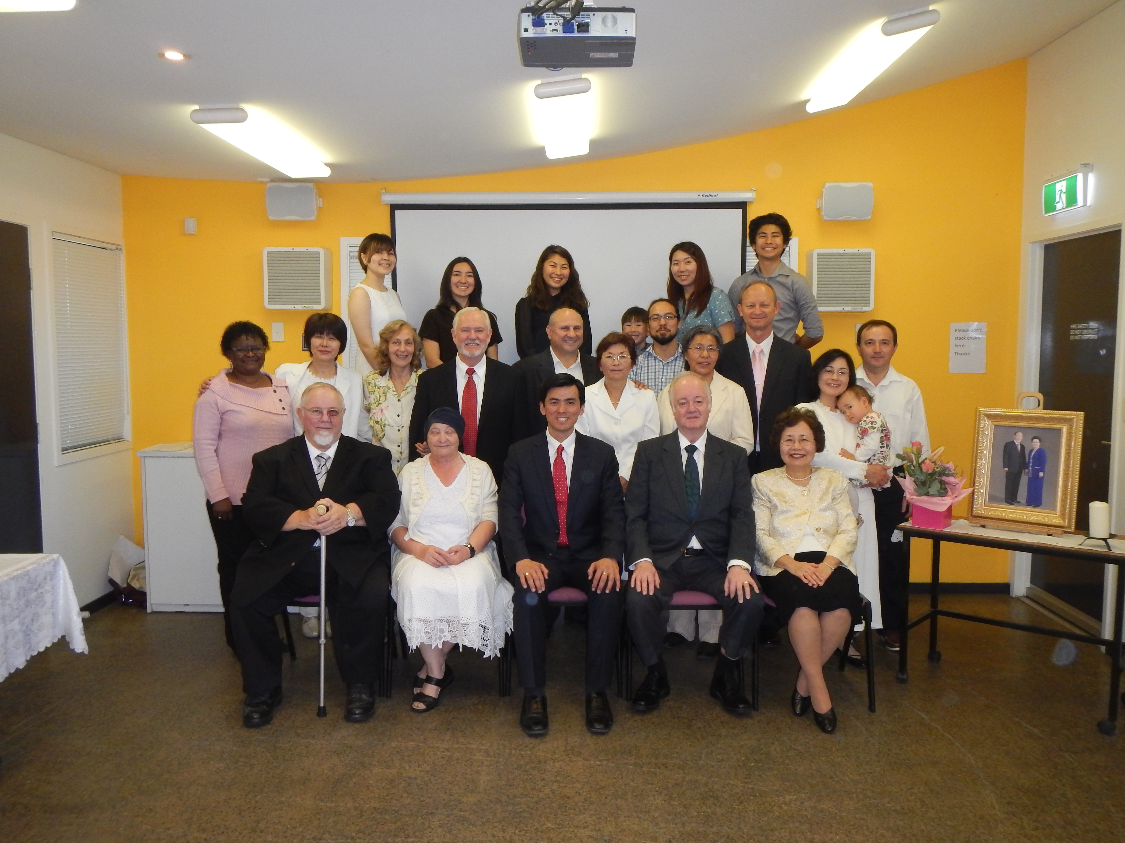
On Sunday the 14th August 2016, Reverend Soon Teck Lim came to Brisbane with the purpose to facilitate the bequethal of the Four Great Items of Cheon Il Guk and Holy Wine Ceremony for members in the Queensland region. These ceremonies are a blessing and a substantial condition for Special Grace at this time in Heavenly Parent’s providence.
On a beautiful Sunday morning twenty four members gathered to participate in the ceremony, with those unable to attend being able to participate in another ceremony at a later date.
The program was in the format of previous ceremonies in Sydney and Melbourne including a spirit filled rendition of the Cheon Il Guk National Anthem , followed by Family Pledge.
John Adamedes gave an appropriate invocation prayer that reminded us of providential history leading to this point and the significance of True Parent’s conditions to allow this Special Grace for blessed families.
Soon Teck Lim gave an address about the Holy Items of Cheon Il Guk and the significance of the Holy Wine. This summarized a more complete explanation during special education held in July at the same venue.
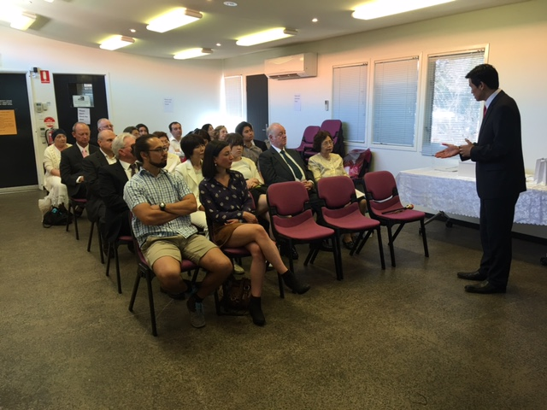
All participants then partook of the Holy Wine as Blessed Couples and Blessed children.
Participants could then have some reflection time to complete our Statement of Resolution. Such a resolution requires deep thought, repentance and redetermination, it is hoped that those who didn’t have sufficient time or couldn’t focus in the group atmosphere can continue to reflect about this new start that comes with this Special Grace. The resolution papers were then offered to Heavenly Parent’s family by family.
Soon Teck Lim then presented each family with the Holy Items of Cheon Il Guk Candle, Consecrated Soil and Salt.
We then received a Benediction from True Parent’s in the form of True Mother’s prayer at the original presentation of the Holy Items. It is a deeply moving prayer reflecting Heavenly Parent’s heart ache for failures but of love for His children and His hope for unity and reconciliation centred on True Parents.
The ceremony was closed by Steve Evans as he conducted a rousing three cheers of “Eog Mansei!”

report by Kim Raymond

